Boolean Algebra Review
John F. Wakerly – Digital Design. 4th edition. Chapter 4.

- Goal – Represent the application of Boolean algebra theoretical knowledge.
- Learning outcome - by the end of this class the students should become familiar with the switching functions, SOP, truth tables, main theorems and be able to use this class topics as a reference in the further work on this course.

The postulates below and some Boolean Algebra basics are brought as a reference for using in combinational logic design. The red color texts are mandatory to learn in details to be able to use them in further classes.

Fundamentals of Boolean Algebra

Basic Postulates
- Postulate 1 (Definition): A Boolean algebra is a closed algebraic system containing a set K of two or more elements and the two operators • and +.
- Postulate 2 (Existence of 1 and 0 element):
(a) a + 0 = a (identity for +), (b) a • 1 = a (identity for •)
- Postulate 3 (Commutativity):
(a) a + b = b + a, (b) a • b = b • a
- Postulate 4 (Associativity):
(a) a + (b + c) = (a + b) + c (b) a• (b•c) = (a•b) •c
- Postulate 5 (Distributivity):
(a) a + (b•c) = (a + b) •(a + c) (b) a• (b + c) = a•b + a•c
- Postulate 6 (Existence of complement):
(a) 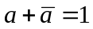 (b) 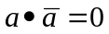
- Normally • is omitted.

Fundamental Theorems of Boolean Algebra

Theorem 1 (Idempotency):
(a) a + a = a(b) aa = a
Theorem 2 (Null element):
(a) a + 1 = 1(b) a0 = 0
Theorem 3 (Involution)

Properties of 0 and 1 elements

ORANDComplement
a + 0 = aa0 = 00' = 1
a + 1 = 1a1 = a1' = 0
Theorem 4 (Absorption)
(a) a + ab = a(b) a(a + b) = a

Examples:
(X + Y) + (X + Y)Z = X + Y[T4(a)]
AB'(AB' + B'C) = AB'[T4(b)]

Theorem 5
(a) a + a'b = a + b(b) a(a' + b) = ab

Examples:
B + AB'C'D = B + AC'D
(X + Y)((X + Y)' + Z) = (X + Y)Z

- Theorem 6
(a) ab + ab' = a (b) (a + b)(a + b') = a

- Examples:
- ABC + AB'C = AC
- (W' + X' + Y' + Z')(W' + X' + Y' + Z)(W' + X' + Y + Z')(W' + X' + Y + Z)
= (W' + X' + Y')(W' + X' + Y + Z')(W' + X' + Y + Z)
= (W' + X' + Y')(W' + X' + Y)
= (W' + X')

- Theorem 7
(a) ab + ab'c = ab + ac (b) (a + b)(a + b' + c) = (a + b)(a + c)

- Examples:
- wy' + wx'y + wxyz + wxz' = wy' + wx'y + wxy + wxz'
= wy' + wy + wxz'
= w + wxz'
= w
- (x'y' + z)(w + x'y' + z') = (x'y' + z)(w + x'y')

Theorem 8 (DeMorgan's Theorem)
(a) (a + b)' = a'b'(b) (ab)' = a' + b'

Generalized DeMorgan's Theorem
(a) (a + b + … z)' = a'b' … z'(b) (ab … z)' = a' + b' + … z'

Examples:
(a + bc)'= (a + (bc))'
= a'(bc)'
= a'(b' + c')
= a'b' + a'c'
Note: (a + bc)' ≠ a'b' + c'

More Examples for DeMorgan's Theorem
(a(b + z(x + a')))' = a' + (b + z(x + a'))'
= a' + b' (z(x + a'))'
= a' + b' (z' + (x + a')')
= a' + b' (z' + x'(a')')
= a' + b' (z' + x'a)
= a' + b' (z' + x')

(a(b + c) + a'b)'= (ab + ac + a'b)'
= (b + ac)'
= b'(ac)'
= b'(a' + c')

Theorem 9 (Consensus)
(a) ab + a'c + bc = ab + a'c (b) (a + b)(a' + c)(b + c) = (a + b)(a' + c)

Examples:
AB + A'CD + BCD = AB + A'CD
(a + b')(a' + c)(b' + c) = (a + b')(a' + c)
ABC + A'D + B'D + CD = ABC + (A' + B')D + CD
= ABC + (AB)'D + CD
= ABC + (AB)'D
= ABC + (A' + B')D
= ABC + A'D + B'D

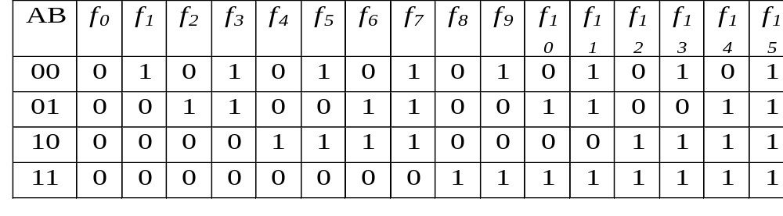
Switching Functions
Switching algebra: Boolean algebra with the set of elements K = {0, 1}
If there are n variables, we can define
switching functions.
Sixteen functions of two variables:

A switching function can be represented by a table as above, or by a switching expression as follows:
f₀(A,B)= 0, f₆(A,B) = AB' + A'B, f₁₁(A,B) = AB + A'B + A'B' = A' + B, ...
Value of a function can be obtained by plugging in the values of all variables:
The value of f₆ when A = 1 and B = 0 is:
= 1 + 0 = 1.

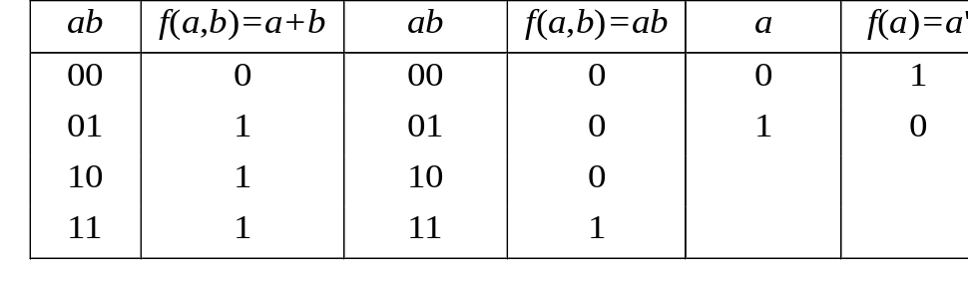
Truth Tables
Show the value of a function for all possible input combinations.
Truth tables for OR, AND, and NOT:

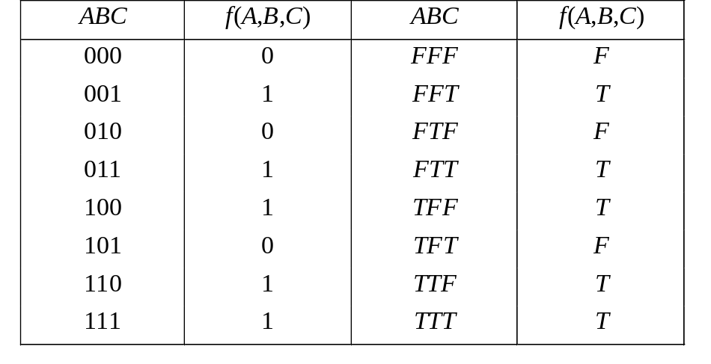
- Truth tables for f(A,B,C) = AB + A'C + AC'

Algebraic Forms of Switching Functions
Literal: A variable, complemented or uncomplemented.
Product term: A literal or literals ANDed together.
Sum term: A literal or literals ORed together.

SOP (Sum of Products):
ORing product terms
f(A, B, C) = ABC + A'C + B'C

POS (Product of Sums)
ANDing sum terms
f (A, B, C) = (A' + B' + C')(A + C')(B + C')

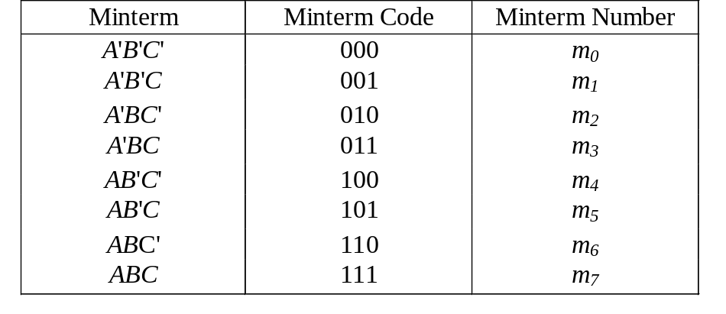
A minterm is a product term in which all the variables appear exactly once either complemented or uncomplemented.
Minterms of three variables:
- Canonical Sum of Products (canonical SOP):
- Represented as a sum of minterms only.
- Example: f₁(A,B,C) = A'BC' + ABC' + A'BC + ABC

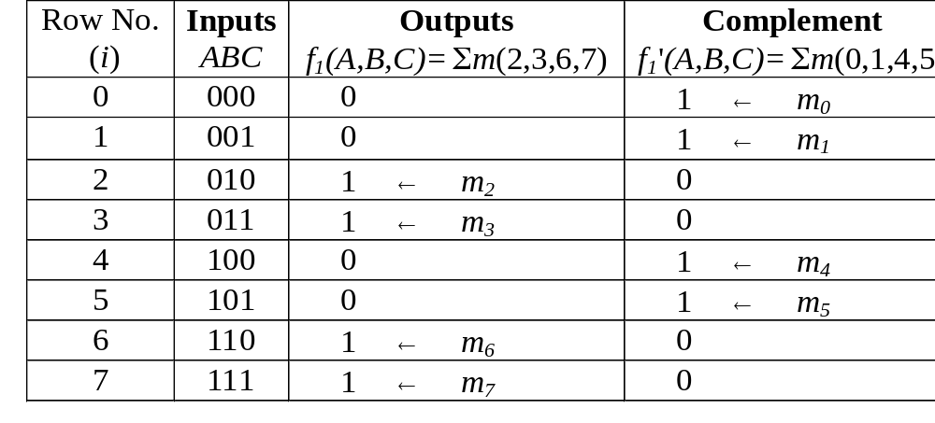
Compact form of canonical SOP form:
f₁(A,B,C) = m2 + m3 + m6 + m7
A further simplified form:
f₁(A,B,C) = Σ m (2,3,6,7) (minterm list form)
The order of variables in the functional notation is important.
Deriving truth table of f₁(A,B,C) from minterm list:

